PREDEVELOPMENT RETAINER AGREEMENT
THIS PREDEVELOPMENT RETAINER AGREEMENT (the “Agreement”) is entered into as of the 17th day of September, 2018, by and between the COLORADO SPRINGS URBAN RENEWAL AUTHORITY, a body corporate and politic of the State of Colorado (the “Authority”), and Blue and Silver Development Partners, LLC a Colorado corporation (the “Developer”).
RECITALS:
WHEREAS, a Conditions Study will be completed for the study area as shown on Exhibit A (as may be modified pursuant to Section 5 below);
WHEREAS, based on the determination of blighted conditions present in the study area, an urban renewal plan or plans (collectively, the “Plan”) will be prepared for all or a portion of the study area as determined by the Developer and the Authority;
WHEREAS, Developer is the owner of private property (or intends to obtain agreements with other property owners to allow the inclusion of their properties in the Plan) (the “Property”) and all such Property would be subject to the Plan;
WHEREAS, Developer intends to develop the Property in accordance with the uses to be specified in the Plan;
WHEREAS, the parties anticipate that a Redevelopment Agreement setting forth the improvements to be constructed by Developer in furtherance of the Plans and any reimbursement or other public finance provisions related thereto (“Redevelopment Agreement”) and the other project’s agreements (as defined below) will be negotiated, drafted and entered into in the future setting forth in detail the agreements between the Authority and the Developer relating to development of all or a portion of the Property and use of the tax increment financing generated within the areas included within the Plan.
NOW THEREFORE, in consideration of the above recitals and the covenants and conditions of this Agreement, the parties agree as follows:
1. The Developer shall pay to the Authority, upon the execution of this Agreement, a retainer deposit in the amount of $60,000.00 in immediately available funds (the “Deposit”). The Deposit is intended to secure the obligation of the Developer to compensate the Authority for reasonable costs and expenses of the Authority, an estimate of which is shown on Exhibit B, in connection with undertaking, without limitation, the Conditions Study, City Council approval of the Plan and the negotiation, drafting, execution and performance of (i) the Redevelopment Agreement, (ii) a Sales Tax Cooperation Agreement with the City of Colorado Springs, and (iii) other inter-governmental agreements between the Authority, Developer, City, County, School Districts and/or other taxing authorities related to the foregoing (collectively, the “project’s agreements”).
2. The Authority will deposit the Deposit into an account owned by the Authority. If the account is an interest-bearing account, all interest will accrue and be added to the amount of the Deposit.
3. The Authority shall be entitled to withdraw funds from the Deposit from time to time, subject to the provisions of Section 5, for reasonable costs and expenses incurred in connection with the project’s agreements. Such expenses shall include, but shall not be limited to, studies (such as economic impact reports, market feasibility studies, etc.), legal fees, financial review, time allocated by Authority’s staff to the project (billed at the following initial rates, subject to reasonable increases from time to time upon notice to Developer: Executive staff $250.00 per hour, administrative office staff $35.00 per hour, plus 15% of the foregoing hourly rates for office overhead), hard costs and expenses, and other third-party consultants’ fees and expenses.
4. The Authority shall periodically (but no less often than quarterly) send to Developer a written reconciliation summary of its use of the Deposit. At such time as the initial Deposit is less than $3,000.00, (or reasonably projected to be less than $3,000.00 based upon anticipated necessary expenditures in connection with the project’s agreements), the Authority shall notify Developer of the amount of additional funds needed to replenish the Deposit. The Developer shall pay such additional amount within ten (10) days of the date of such notice. Any such payments will be made pursuant to the provisions of Section 5 regarding a scope of work (the “Scope”) agreed to among the parties to this Agreement. The parties to this Agreement understand that the total cost for any Scope may not be known in advance. However, the Authority will provide an estimate of cost for each Scope, which shall not be binding on the Authority but which will provide the Developer with an estimate for its budgeting purposes. The Authority (its staff and consultants) shall be entitled to cease all work on the project until such time as the additional funds have been received. Upon completion of the project agreements, or earlier upon a written agreement which specifically supersedes the payment provisions of this Agreement, any funds remaining in the Authority’s project account shall be returned to the Developer.
5. Upon payment of the Deposit, the parties hereto will proceed with good faith and reasonable diligence to finalize the Conditions Study and Urban Renewal Plan.
The Authority and the Developer agree that work necessary to the documentation and implementation of the Plan should proceed based upon a mutually agreed upon Scope. The purpose is to allow both parties to focus their efforts on the agreements, studies, financial analysis and other work products deemed timely, to direct the financial resources towards the costs associated with each scope of work and to allow the parties to make reasonable estimates regarding the funding requirements of Section 4 above. The initial Scope shall include, as necessary and appropriate:
A. Preparation of a Conditions Study and Urban Renewal Plan (in the Board’s discretion) as per the Scope of Services prepared by Ricker Cunningham dated September 12th, 2018, with the understanding that Developer may modify or reduce the study area or Plan area.
B. Preparation and execution of a Cooperation Agreement (with board approval) between the City of Colorado Springs and the Authority.
C. Preparation and execution of a Redevelopment Agreement (with board approval) between the Authority and the Developer.
D. Preparation and execution of inter-governmental agreements between the Authority, Developer, City, County, School Districts and/or other taxing authorities (with board approval) related to the foregoing.
6. In the event Developer fails or refuses to pay the additional sums required pursuant to Section 4 above, in addition to the Authority’s right to cease all further work on the project, to the extent the Authority is obligated to pay (or entitled to reimbursement of) sums reasonably incurred in furtherance of this Agreement, the Authority shall be entitled to collect all such sums from the Developer, and Developer shall be liable to pay such amounts to the Authority. Additionally, the Authority shall be awarded all costs and expenses incurred by the Authority in connection with such collection action, including its reasonable attorneys’ fees and costs.
7. This Agreement shall specifically survive the execution and performance of the project’s agreements (except as specifically set forth therein), and shall be binding upon the parties hereto and their respective heirs, successors and assigns.
* * * * * *

IN WITNESS WHEREOF the parties have entered into this Agreement effective as of the date first above written.

COLORADO SPRINGS URBAN RENEWAL AUTHORITY

By:__________________________________________
Wynne Palermo, Chair

Blue and Silver Development Partners, LLC

By: ____________________________________
Name: ____________________________________
Its: ____________________________________

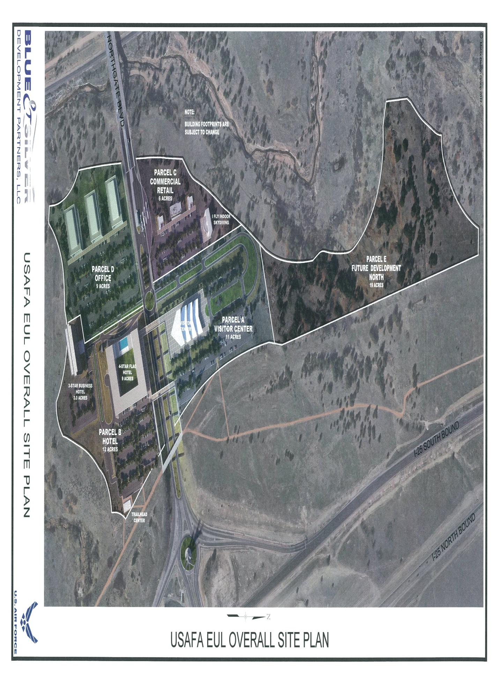EXHIBIT B
Estimated Urban Renewal Plan Fees

DESCRIPTION | Ricker Cunningham | CSURA | Task  Total
Conditions Survey | 10,500.00 | 4,000.00 | $14,500.00
Urban Renewal Plan | 13,500.00 | 4,000.00 | $17,500.00
Political Consultant Fee |  | 12,000.00 | $12,000.00
Legal Description | TBD | 0.00 | TBD
Administrative Costs |  | 250.00/hr | TBD
County/ School Impact Reports | 750.00 (each) | 500.00 (each) | $1,250.00 (each)
2 Additional Impact Reports | TBD | TBD | TBD
Meetings & Presentations | 1,500.00 | 3,000.00 | $4,500.00
Legal and third party review |  | TBD | TBD
Redevelopment Agreement |  | 10,000.00 | $10,000.00
Subtotal | $26,250.00 | $33,750.00
TOTAL FEES |  |  | $59,750.00 (plus TBD added costs)
Any fees for additional services will be billed at cost.

Any fees for additional services will be billed at cost.

